# Visualizing Neural Network Hyperparameters with TensorFlow Playground

The [TensorFlow playground](https://playground.tensorflow.org) can be used as an educational visualization to simulate the impact of changing neural network hyperparameters. It will help you to strengthen your deep learning concept.

First, we will start with understanding some of the terms by following the numbers from 1 to 8 depicted in the below picture.

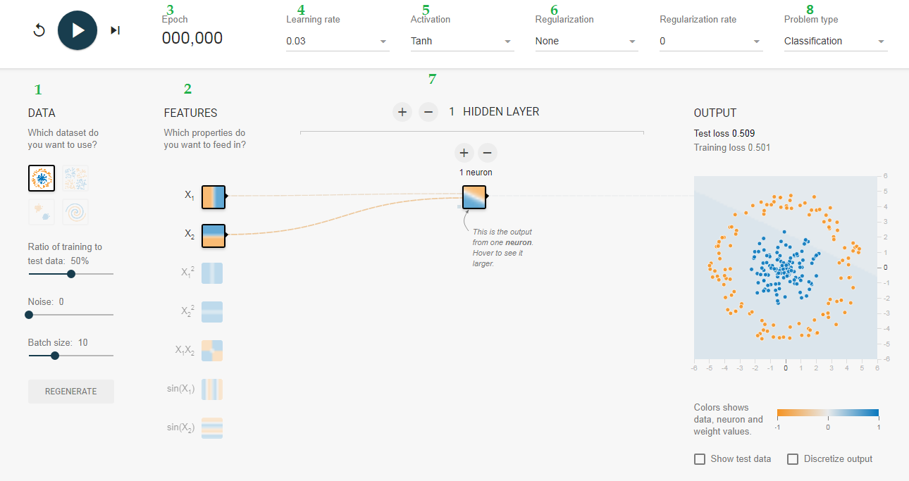

**1- Data**

The four datasets: circular, 4 quadrants, 2 clusters, and a swirl

**2- Features**

We have seven features or inputs (X1, X2, squares, product and sine). We can turn on and off different features to see which features are more important.

**3- Epoch**

Epoch is one complete iteration through the data set.

**4- Learning Rate**

*Learning rate (alpha)* is the hyperparameter which is responsible for the speed to approach the local optima.

**5- Activation Function**

An activation function is a node that you add to the output layer or between two layers of any neural network. The activation functions are basically of two types linear & non-linear.

**6- Regularization**

The purpose of regularization L1 and L2 is to reduce overfitting. **Overfitting** is when a model works very well for the data that it was trained on but the model provides a poor prediction for any data it hasn’t seen before.

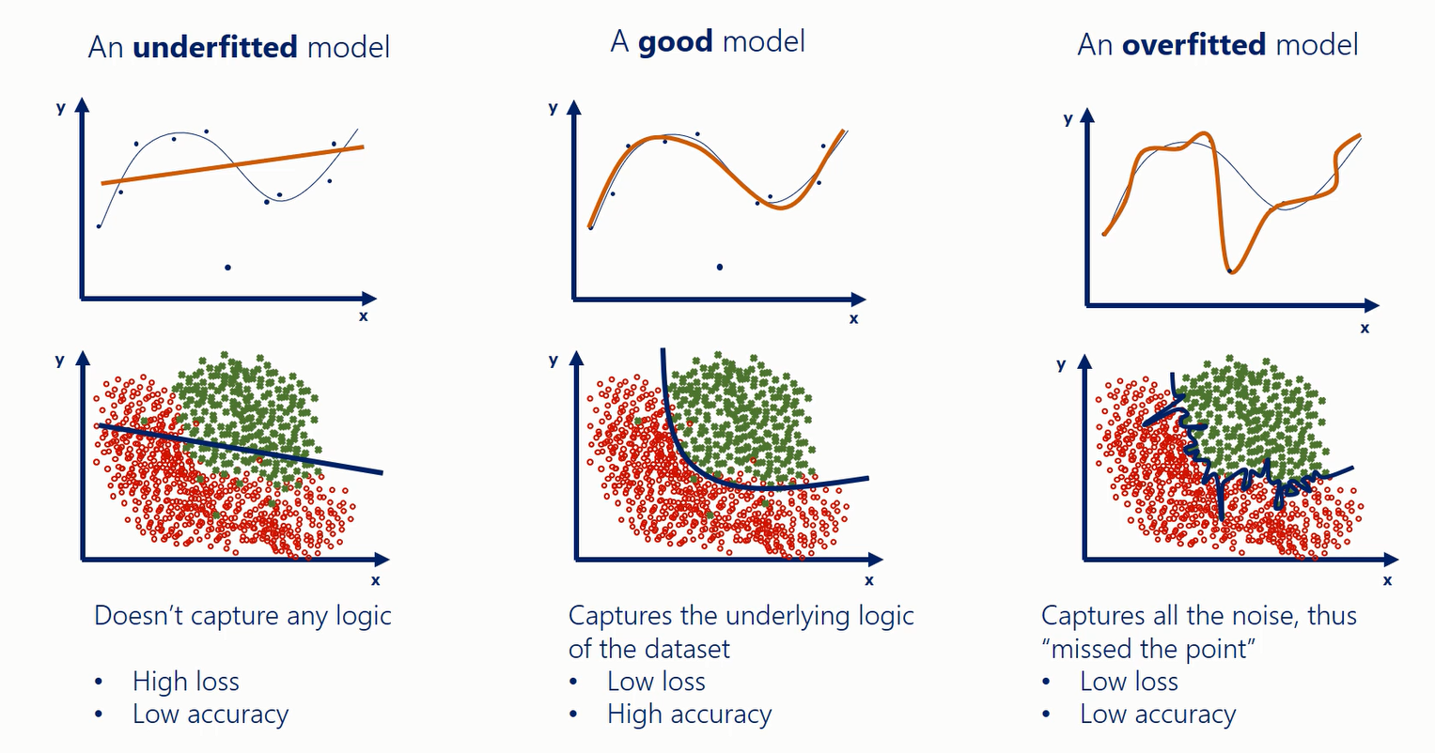

**7- Neural Network Model or Perceptron**

A neural network model is a network of simple elements called neurons, which receive input, change their internal state (activation) according to that input, and produce output (0 or 1) depending on the input and activation. We have one input, one output and at least one hidden layer in the simplest neural network called shallow neural network. When the hidden layers are 3 or more then we called it a deep neural network. Each hidden layer has actual working elements called neurons that take input from features or predecessor neurons and calculate a linear activation function (z) and an output function (a).

**8- Problem Type**

We have four data sets for classification and two for the regression problem. You can select the type of problem you want to study.

**Before we're going to discuss in full detail the hyperparameters tuning in the next chapter, you are really encouraged to check TensorFlow playground out and visualize everything we've been talking about.**

Exercise:

Go ahead and Open your browser to: <https://playground.tensorflow.org>

You can start with the basic model with a single neuron in the hidden layer. Let’s pick the dataset ‘Circle’, features ‘X1’ & ‘X2’, 0.03 learning rate and ‘ReLU’ activation. You will press the run button and wait for the completion of a hundred epochs and then click pause.

In the next trials, try the following:

* Try increasing the number of neurons in the hidden layer
* Try running the training with different activation functions (ReLU, sigmoid, tanh and linear).
* Continue experimenting by adding or removing hidden layers and neurons per layer. Also feel free to change learning rates, regularization, and other learning settings to see the impact of fiddling with hyperparameters on the training model.